3D sketching!

A tad hard to get started but makes fuselage design a million times easier

1. Start a sketch as usual
   1. 
   2. 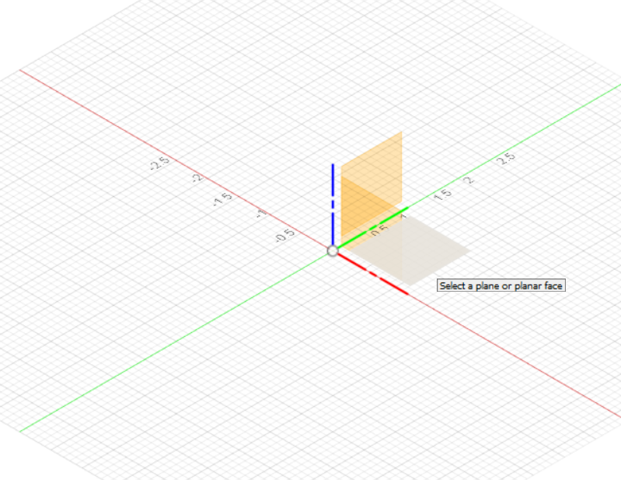
2. Open up the sketch pallet on the right side
   1. Make sure you have “3D Sketch” on the very bottom checked on
   2. 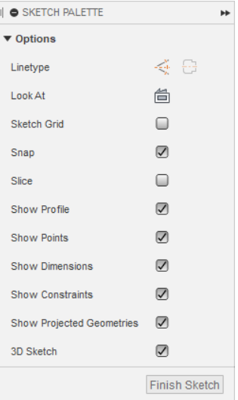
3. Square on the plane and fully constrain it

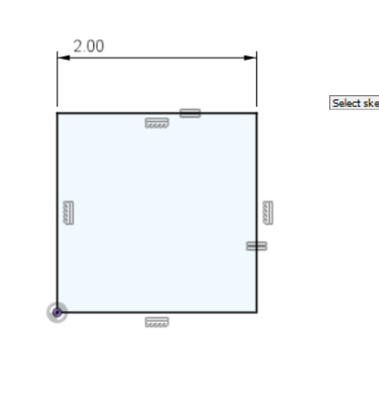

1. Ok now rotate your view so you’re looking at it like this: 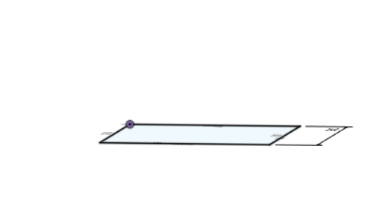

Basically flat but just a little tilted so you can see all 4 corners

1. Start a line
   1. You’ll immediately see these 3 axis 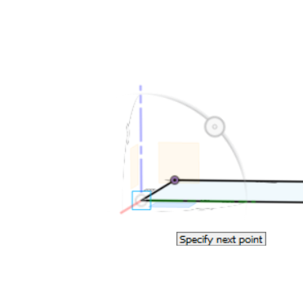
   2. Make your line follow the axis that’s pointing straight up
   3. 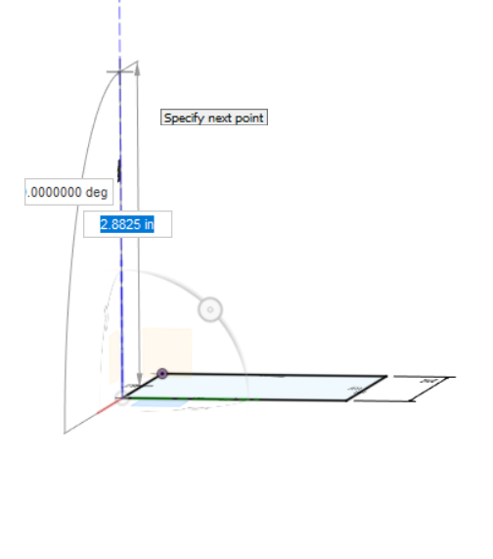
2. You should have something like this! Where it is in a 3D space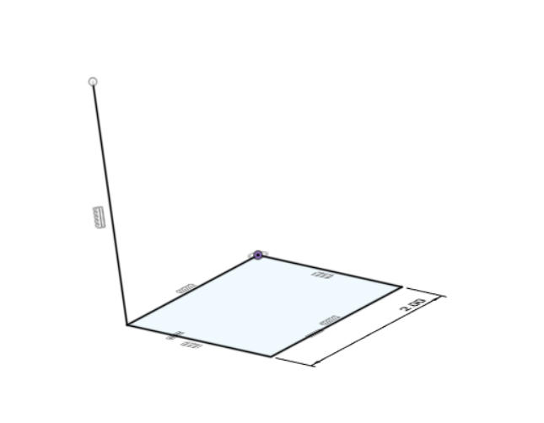
3. Alright now you’re going to continue following the 3 axis lines until you make a cube. Remember to use the “equal” constraint to ensure it’s a perfect cube
   1. Process pics: 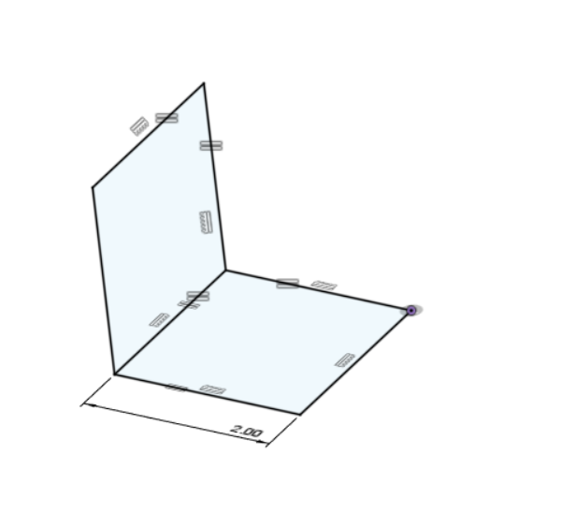
   2. Don’t fret if you can’t get it exactly shaped like a cube at first
   3. 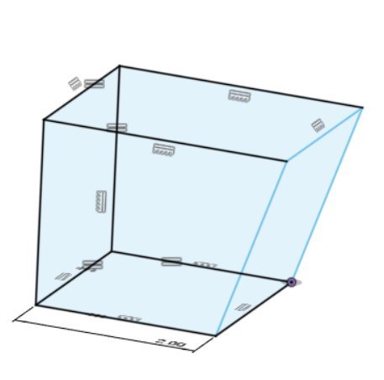
   4. Just use the equal tool:
   5. 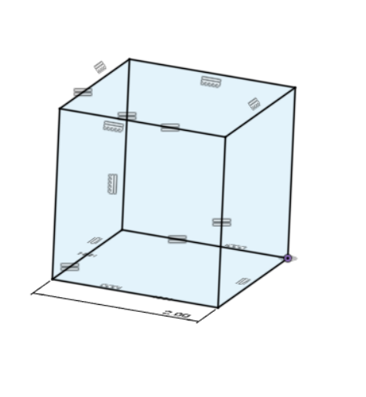
4. Sweet! You’ve made your first 3D sketch!
5. Saving it: as usual:
   1. 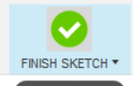
   2.  → 
   3. Name it something like [your name] - [ lol whatever you want]
   4. Just make sure you save it in design team > practice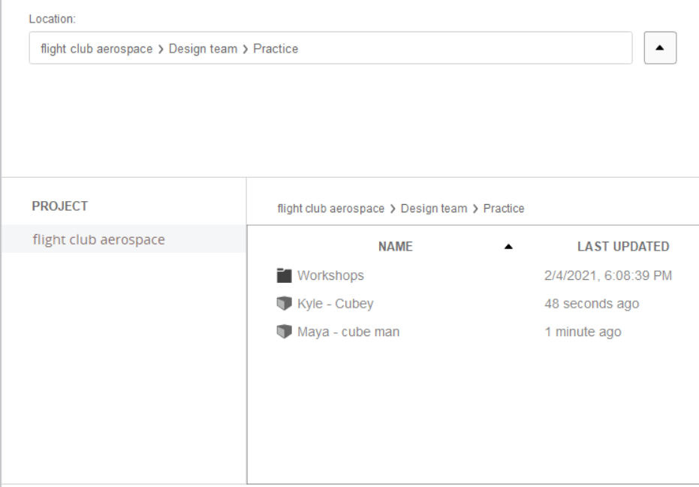

Piping

# Background:

We do not extrude pipes on FCA - instead we use the pipe tool Fusion already supplies because it welds it for us.

**Ex. with extruded tubing:**

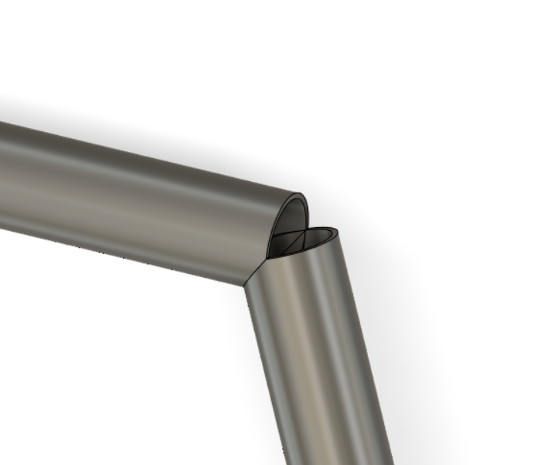

**With the pipe tool:**

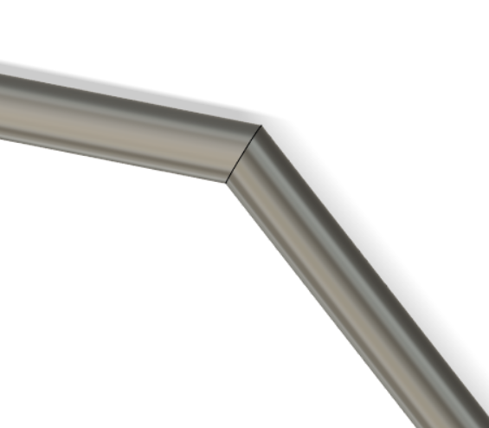

A million times better right? It also works better in simulation and will better inform the exact dimension of tubing + the angle of notching when we do go to weld our truss together.

Tube notching:

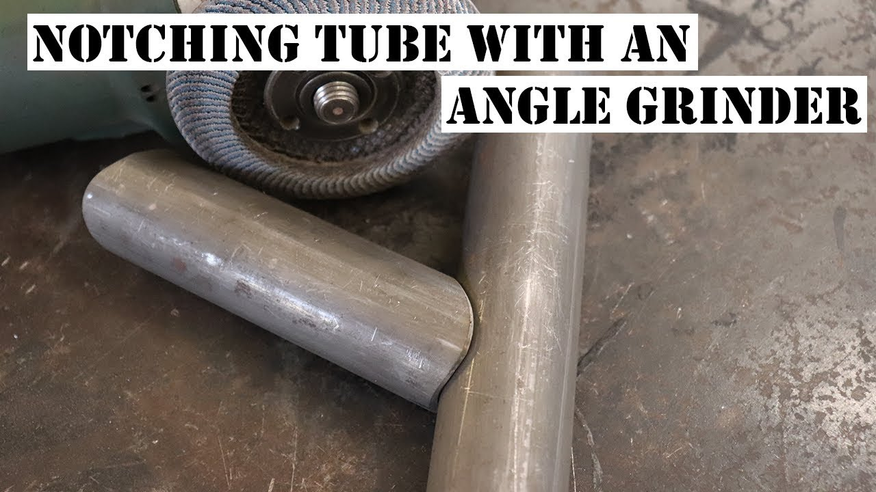

Basically making one tube match the shape of another at a specific angle.

# Lesson Time!

Mkay You should be here: 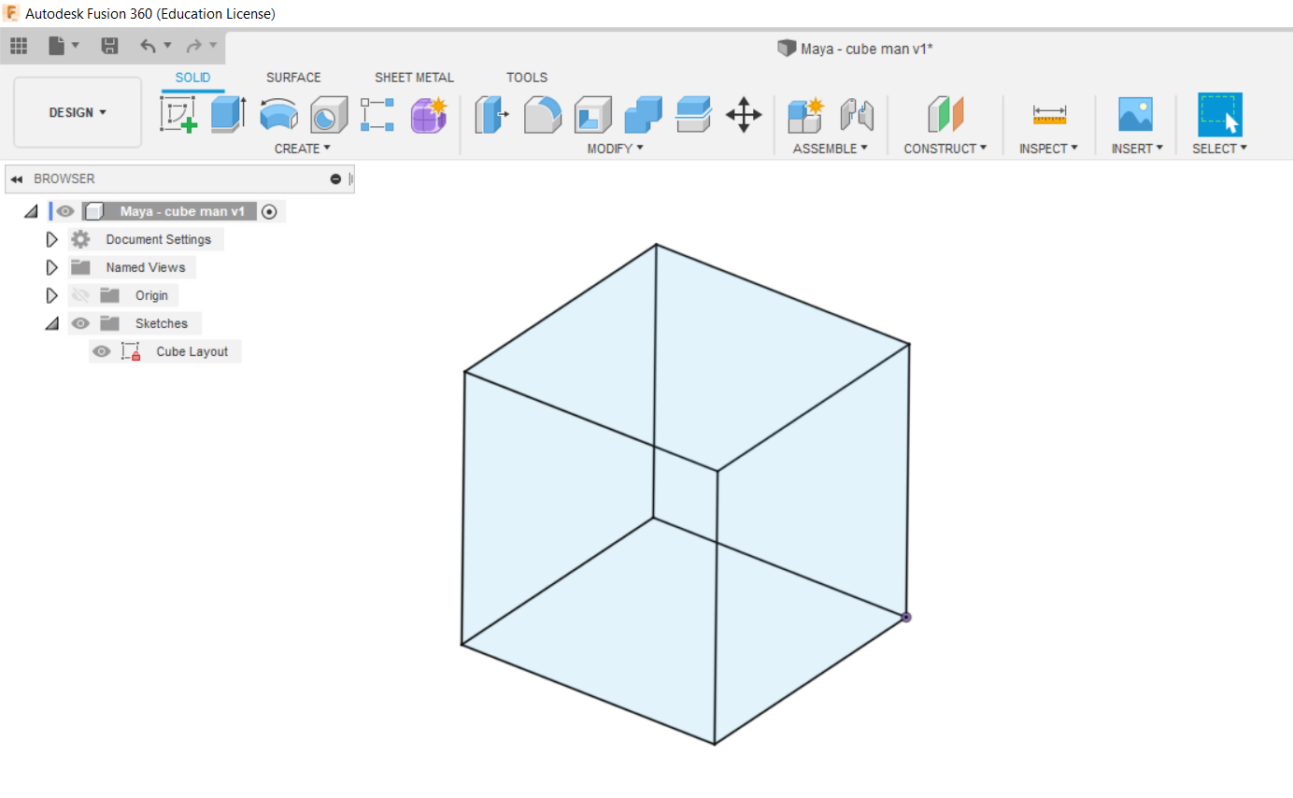

Ok notice how my sketch is named. ALWAYS name your sketches. PLEASE. You can just double click the sketch and rename it that way.

1. Go down to the pipe tool out of the Create drop down.
   1. 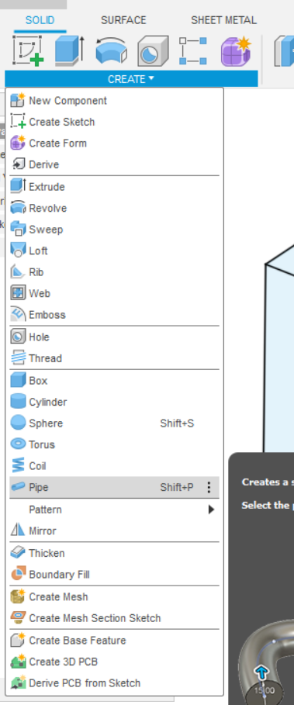
   2. Mine will say “shift + P” because I set it to have that keyboard shortcut.
   3. Recap of keyboard shortcut:
      1. Click the three dots to the right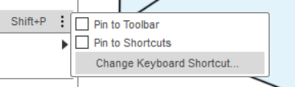
      2. Then change it to whatever you want
2. Ok now select the pipe tool
   1. You should get a popup on the side:
   2. 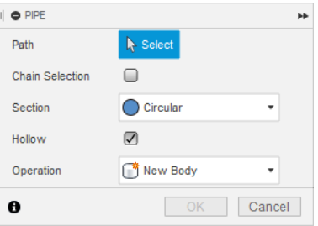
   3. If it doesn’t, make it look like it
3. Click one of the lines you consider to be the base of your cube
4. 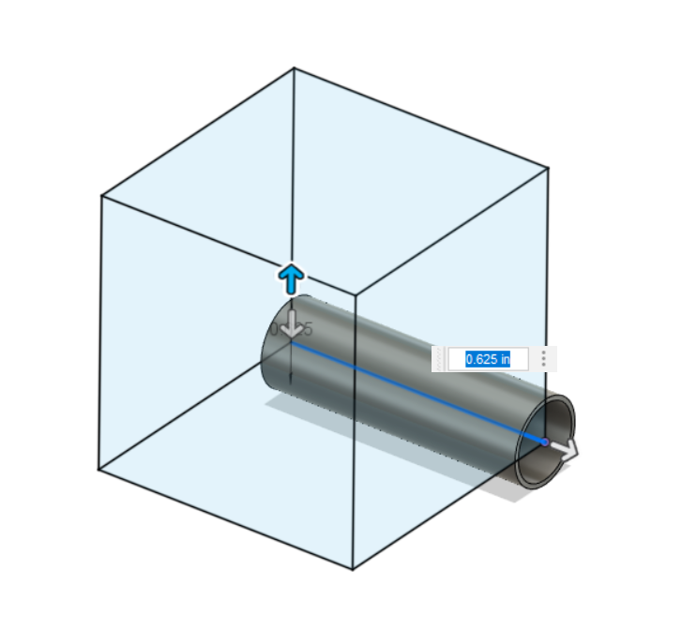
   1. Ok i’m now realizing 2 inches as a base was really small. I’m changing it.
5. OK now your right pipe feature should look like this
   1. 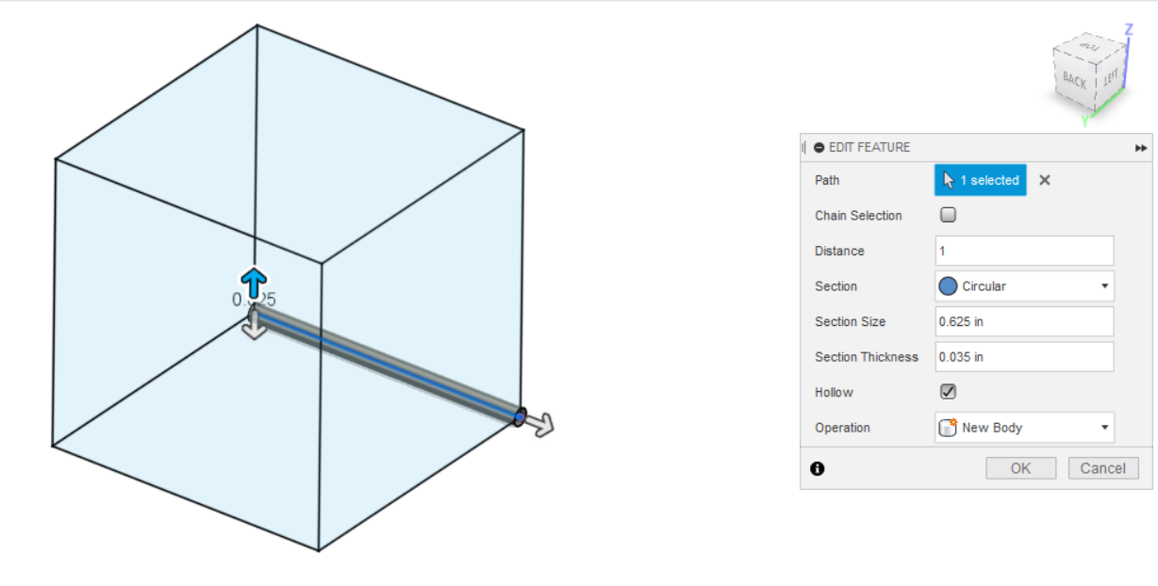
   2. Except it probably doesn’t. All of our tubing on the fuselage is 0.625” outer diameter and 0.035” wall thickness, so that’s what we’ll be using in this tutorial as well.
   3. If you don’t see an option for section thickness: check the “hollow” option.
6. If you did the first beam right you should get something like this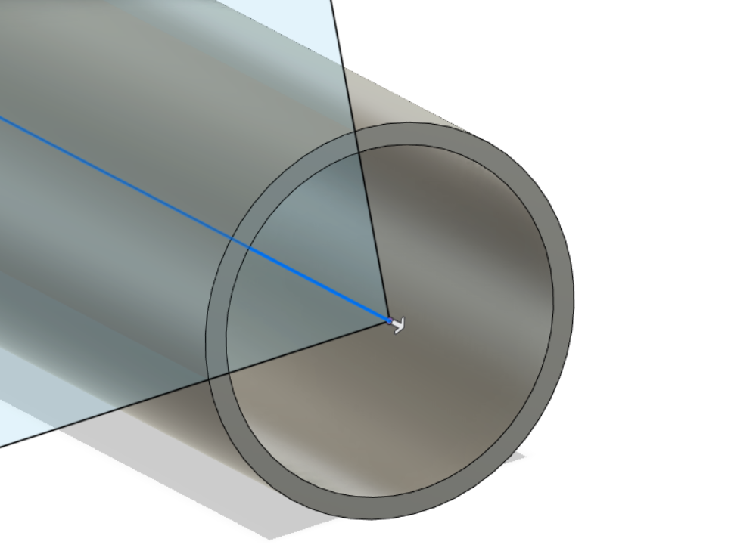
7. Ok let’s do the whole base
   1. 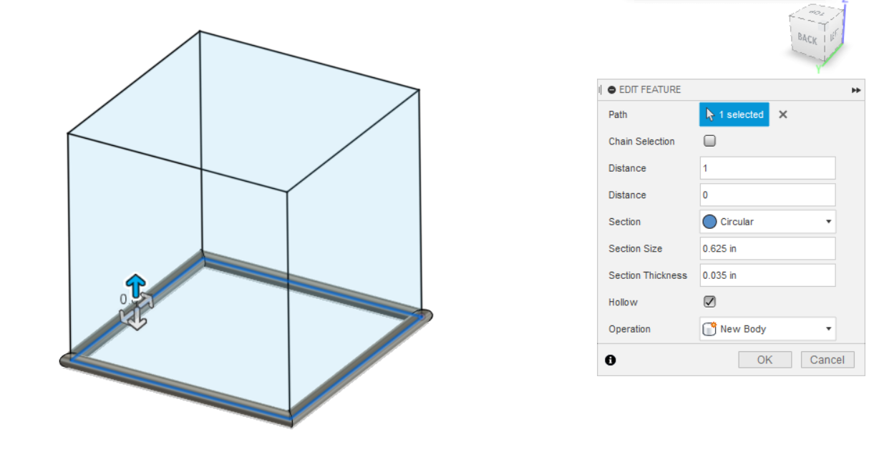
   2. Sweet! You have your base done.
8. Alright now we gotta think about this. We want this all to be one “body” in fusion so we have to strategically pipe the rest of the box.
   1. How I found it to work best is doing the vertical lines individually then doing the top face all at once.
   2. Side Note: if you go to pipe and there’s no lines 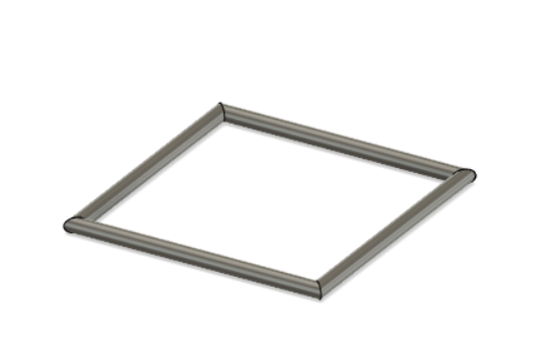
   3. Don’t worry. Just toggle on the eye for the initial sketch
   4.  → 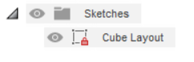
9. Rest of the Cube
   1. If you get a red beam, you’re in cut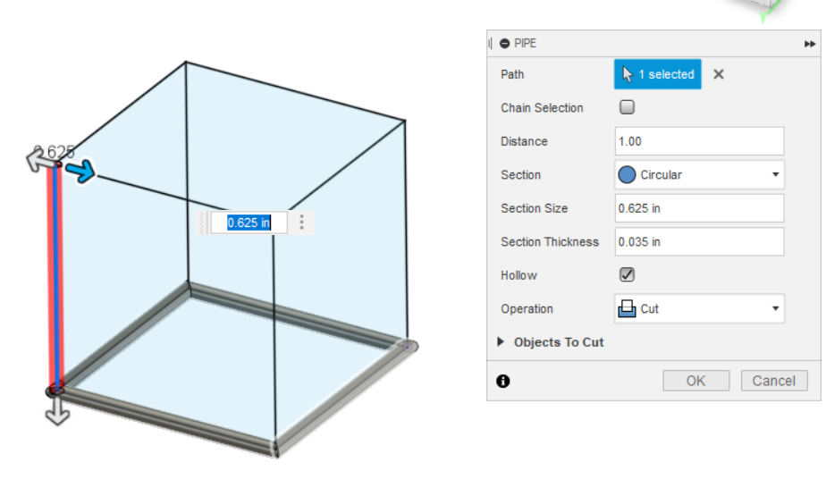 ↓
   2. 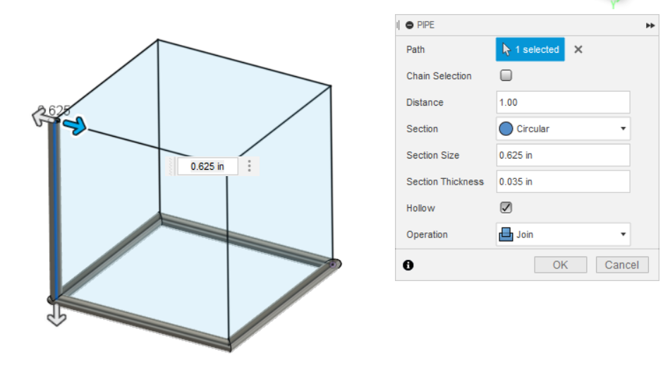
   3. Do the rest of the verticals alone.
   4. Like this: [(link to gif if it doesn’t load)](https://drive.google.com/file/d/1jCh4VQQnnEoXM-C53N8CYaV91tH0TeRg/view?usp=sharing)
   5. 
   6. Note: I used Shift + P for the pipes.
10. Organization!
    1. Go down to the bottom and click the first pipe
    2. 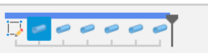
    3. Hold shift on your keyboard and click the most recent pipe
    4. 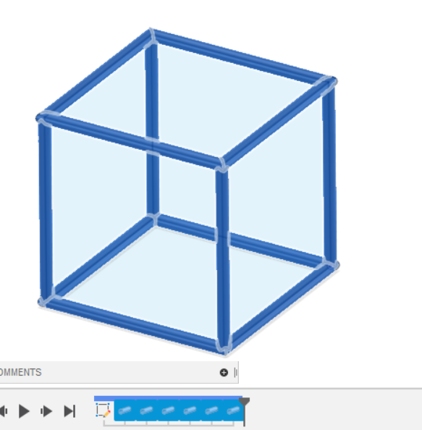
    5. Ok now unclick shift. Right click over the pipes
    6. Click “create group”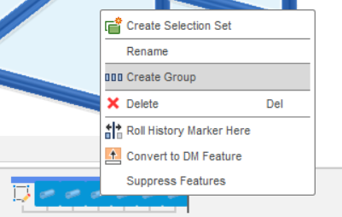
    7. 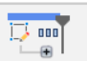
    8. Yeah i think you know what i’m gonna say: rename it!!
    9. Right click over the group 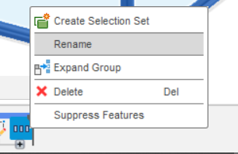
    10. Rename it something intelligent. Or not intelligent, just self explanatory.
11. Sicko mode! You should have this:
    1. 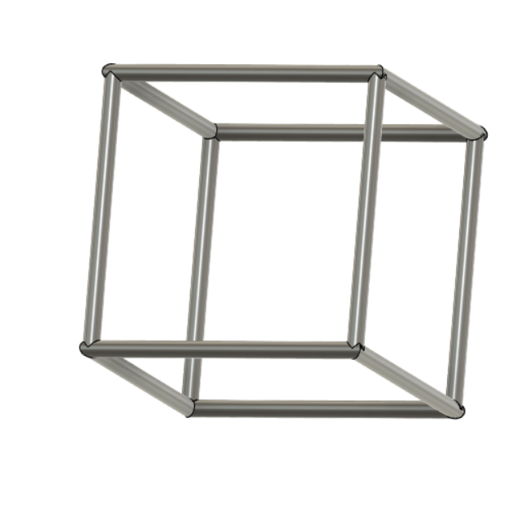

Sweet! You’re almost done with the design tutorials! Head over to [this doc](https://docs.google.com/document/d/1UAabKspkHkIpYLqGVtpGirnyaRd3WSqN-zC-AVyVhVg/edit) and create one thing out of the list or your own! Then post a screenshot.